

DevHive

Team Members: Saeed Haddad, Alaa Al-Taher

Supervisor: Ahamd Al-Tamimi

Graduation Project – Summer 2024

**Introduction**

DevHive is an innovative freelancing platform designed specifically for developers in Jordan. It aims to connect talented developers with clients looking for high-quality tech solutions, fostering a vibrant community of professionals and businesses. With a honey-themed design symbolizing productivity and collaboration, DevHive provides an intuitive and user-friendly interface that streamlines the process of finding and offering freelance services. Whether you're a developer seeking new opportunities or a business in need of expertise, DevHive offers a tailored solution to meet your needs.

**Problem Statement**

In the age of the digital era, people assume that being involved in the tech industry

means having a stable job with high salaries. Unfortunately, this is not the case anymore;

layoffs in tech companies are taking a toll on developers worldwide and it’s only a matter of

time until it hits the Jordanian market; due to the layoffs, some developers choose to join

startups compromising their payments, others start their businesses which prove to be

quite tricky, and some might even change career paths.

**Approach**

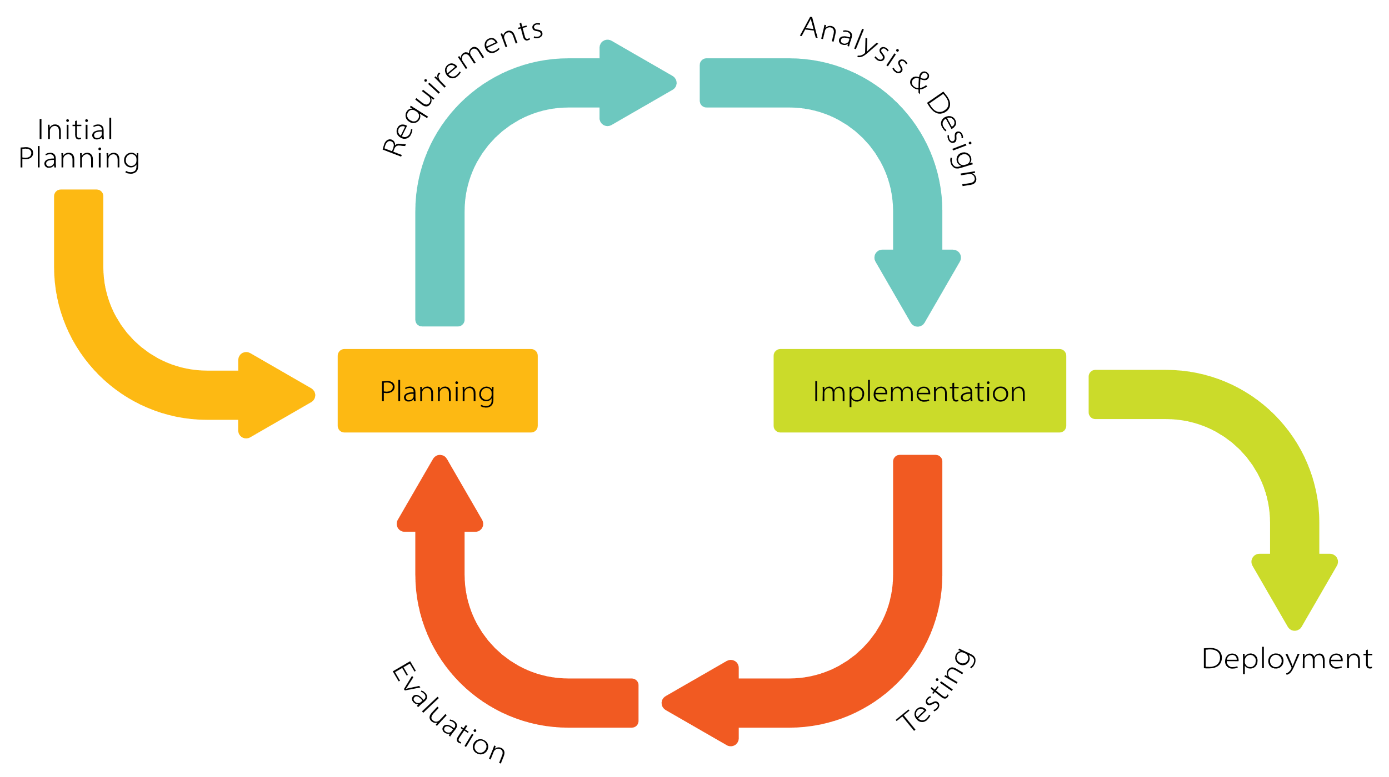

**Features**

**Project Listings:** Clients can post detailed project listings, specifying the skills required, project scope, deadlines, and budget.

**Advanced Search Filters:** Clients and developers can use advanced search filters to quickly find projects or talent that match specific criteria.

**Integrated Chat System:** DevHive includes an in-platform chat system that allows developers and clients to communicate in real-time.

**Interactive Maps for Local Projects:** DevHive features an interactive map integration, allowing clients to find developers within specific geographic locations.

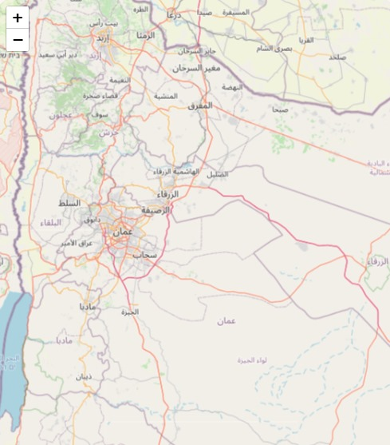

**Conclusion**

DevHive is a comprehensive freelancing platform tailored for developers in Jordan, offering secure payments, collaboration tools, and real-time communication. It provides developers with the resources and opportunities to succeed in a competitive market, fostering growth and innovation in the local tech ecosystem.